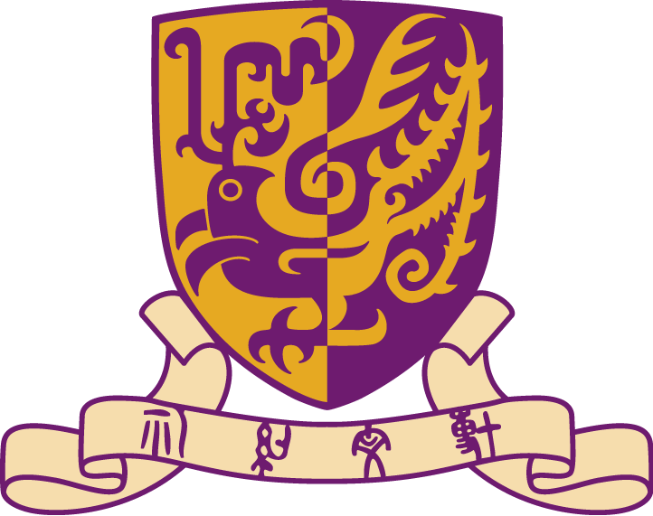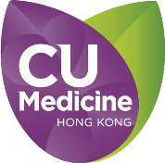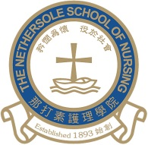
The Chinese University of Hong Kong
Faculty of Medicine
The Nethersole School of Nursing
Inbound Student Exchange Programme 2017

Overview
Duration | 2 weeks from 6 to 17 February 2017
Students | Undergraduates from universities in China, Taiwan, Japan, South Korea, UK, Australia and USA.
Course Overview and Objectives | Aim of the Programme:  The programme aims to provide exchange opportunities for students from other countries to learn about the healthcare system and nursing education in Hong Kong.  Objectives:  - To broaden students’ understanding of the health care delivery system and health care services in Hong Kong.  - To enhance students’ knowledge about the various nursing education programmes in Hong Kong.  - To facilitate students to exchange views and share learning experience with students from other countries.  - To provide opportunities for students to discuss and compare the similarities and differences in the healthcare system and nursing education of their own country and those of other countries.  - To introduce some cultural activities to students.
Prerequisites | None
Activities | Lecture, lab days, clinical visit, cultural activities, and student presentation
Credit units | No
External Affairs Officers (Student) | Ms. Dorothy NS Chan  Phone: +852 3943 8165  Email: dorothycns@cuhk.edu.hk
Contact person | Ms. Sammi Ng  Phone: +852 3943 4039  Email: samming@cuhk.edu.hk

Students’ learning opportunities
Students will be arranged in small groups to attend the following activities:
1. Lecture: ~ 2 – 3 times, 2 hours per time
2. Lab day: ~ 2 – 3 times, 2 hours per time
3. Clinical visits: 2 - 3 times, 2 - 3 hours per time
4. Other activities: Campus tour, library tour, laboratory tour, cultural activities and
student presentation.

Tentative itinerary of the Inbound Student Exchange Programme 2017 for reference:
Date | Topics
6 Feb 2017 (Mon) | - Programme introduction  - Campus tour  - Laboratory tour
7 Feb 2017 (Tues) | Lecture 1: Fundamentals of Nursing I
8 Feb 2017 (Wed) | Lab day 1: Fundamentals of Nursing I
9 Feb 2017 (Thu) | Clinical visit 1
10 Feb 2017 (Fri) | Library tour  Cultural activities
11 Feb 2017 (Sat) | Self-arranged activities
12 Feb 2017 (Sun) | Self-arranged activities
13 Feb 2017 (Mon) | Lecture 2: Introduction to Behavioural & Social Sciences  Clinical visit 2
14 Feb 2017 (Tue) | Lab day 2: Nursing in the Hospital II  Clinical visit 3
15 Feb 2017 (Wed) | Lecture 3: Nursing in Clinical Specialties I
16 Feb 2017 (Thu) | Lab day 3: Nursing in Clinical Specialties I
17 Feb 2017 (Fri) | Sharing session  (sharing of nursing education and health care system among students from various universities)  Self-arranged activities

